**Assignment 1**: Connect and disconnect with login Access

* What happens when you login a non-existent users or username?

Ans:

Screenshot:

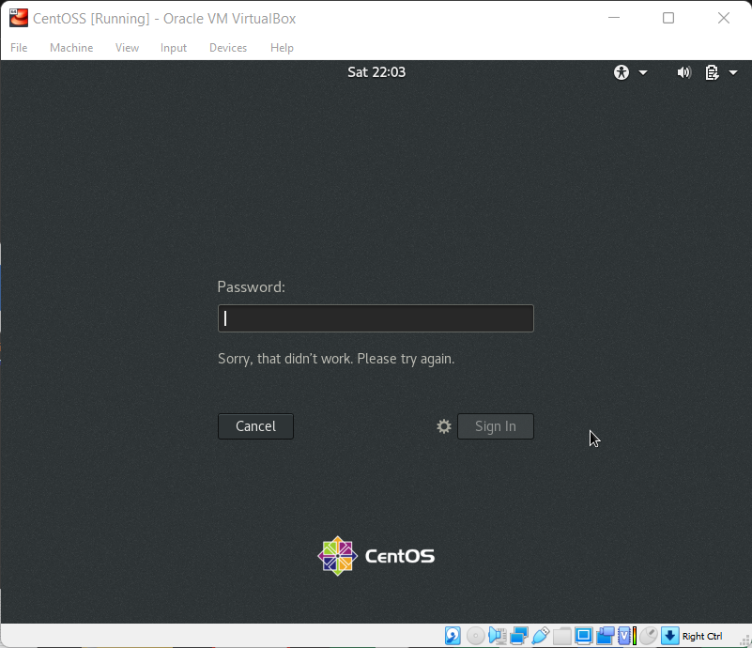

Explanation:

The other user ID was not register and hence I got the error “Sorry, that didn’t work. Please try again”

When we put different username that is not exist in the system or we provide the wrong password its throes the above error. It does not point out what exactly wrong is it the username or password it can be a security feature since here the person who is actually trying to login does not know is it the username that is wrong or the password.

The screen does show the existing username if the person who is trying to login enter the password for the same username, then he will know that it is the password that is wrong however is it’s a different username then it can confuse the person who is trying to hack the server if it’s the username that is wrong of is it the password.

When you sign in back with the actual username and password it tells you if there is any missed attempt of login with actual time.

Assignment-2

Password changing

* Login into your account and then change password?
  + Change your password into ***IneuR0n#42*** and hit the **Enter** key

ANS:

I was able to successfully change the password to ***IneuR0n#42.*** I have realised that if you use a simple combination and make 15 word long password still Linux will not show it as a strong password. When you use a complex combination like ***IneuR0n#42,*** password is small however it will still show you the strong password and also password is hard to remember however you can create a complex combination and easy to remember.

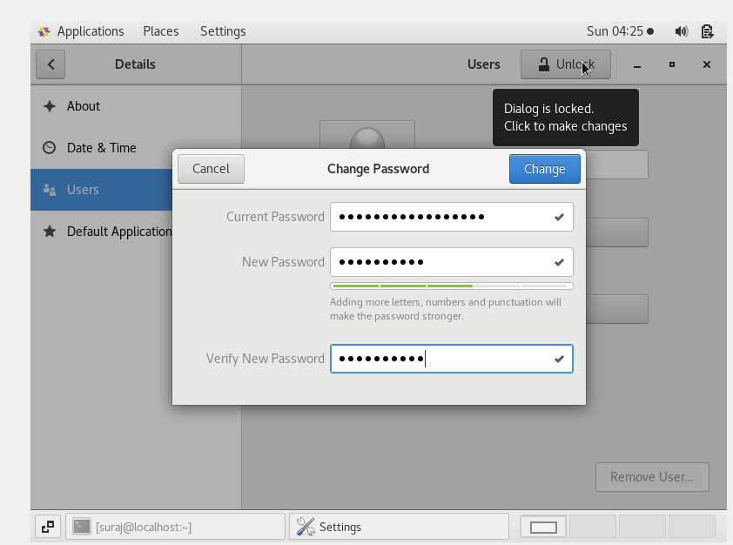Screenshot:

* Explain what happen and give screenshot? Try again to change password but use like password ***1234*** or ***abcd***
  + Explain what happen and give screenshot?

ANS:

When we use abcd or 1234 kind of sequence it gives a warning to avoid those sequence for security reasons as it may be easy to hack.

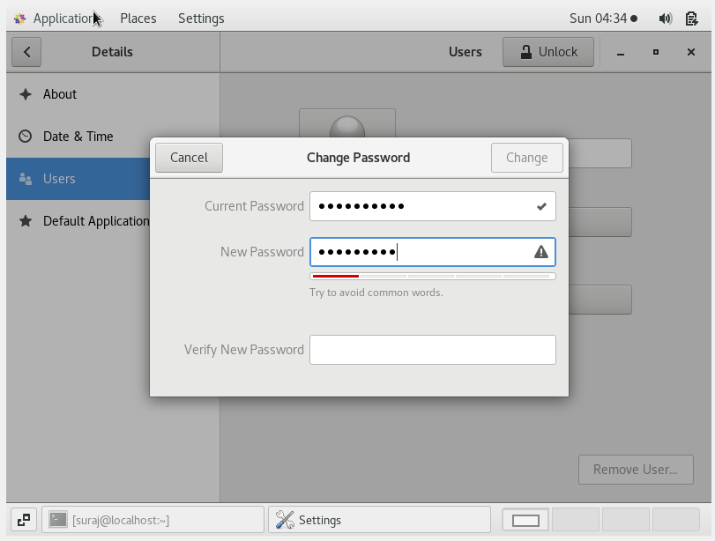Screenshot:

* Try again to change password but now don’t use any password just hit **Enter** key
  + Explain what happen and give screenshot?

ANS:

When we do not enter anything in place of password and it enter the New Password tab will show you a gear icon.

If you click on the gear icon and then it will suggest you the password that you can use.

At Verify New password tab it will show you a warning icon when you hit enter without providing any password.

Screenshot:

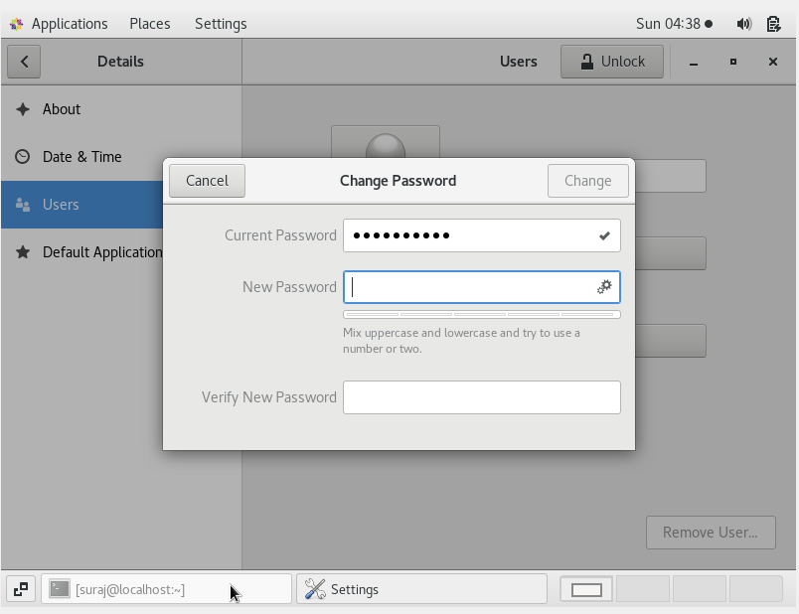

**Assignment-3**

Working with Directories

* Enter the command **cd /** and then **ls** and then hit **Enter** key
  + Take screenshot and explain what output we got?

ANS:

When performed above to command got to know the difference between / and ~.

~ denotes the home directory.

/ denotes the Root files. It contains all the library, cache, bin, root files.

Cd / will rout you to root directory. Where are all the OS related files can be found and you can perform cd / ls or ls after cd / to view the folder in the directory.

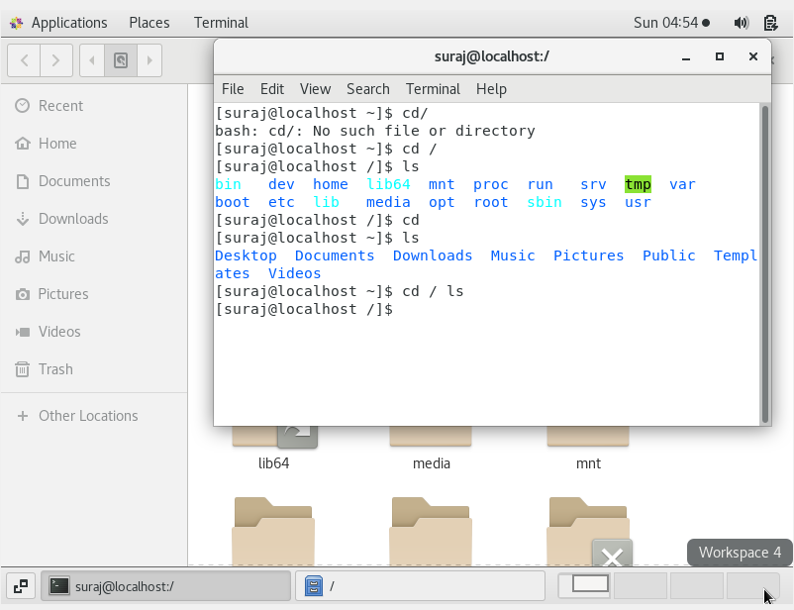Screenshot:

* Enter the command now **cd /home** and then hit **Enter** key
  + Do **ls,** provide screenshot and explain what is **/home** directory used for?

ANS:

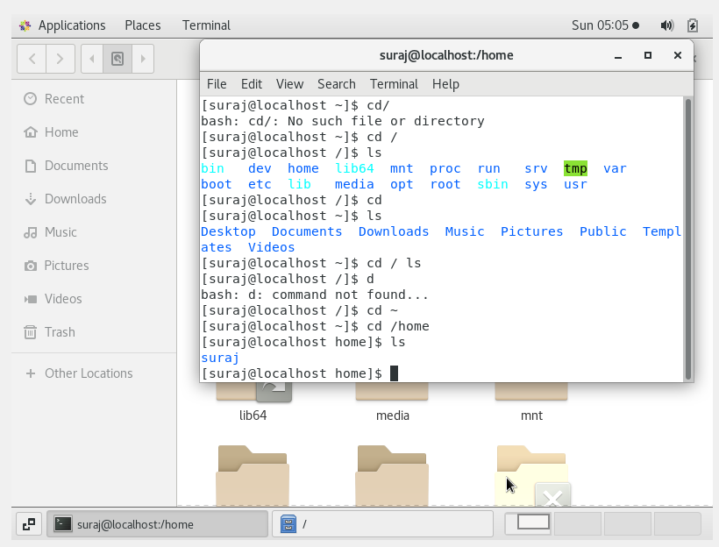

When you do cd /home it will take you to home dir which is Suraj thars why you get Suraj when performed ls.

* Enter **cd ..** and hit **Enter** key [ *Note: here we have space after cd then use double dot*]
  + Check what happen and give screenshot?

ANS:

Cd .. it will take you to previous directory.

As shown in snap I was in iNeuron and then I performed cd .. it takes it back to Desktop.

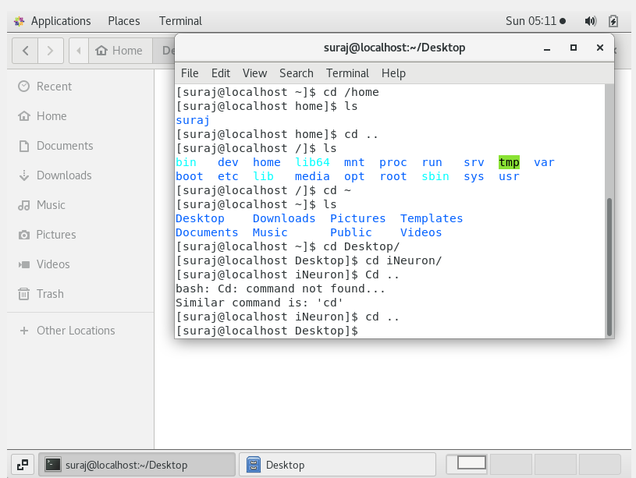

* Now enter **cd /var/www/html** and then type **cd** and hit **Enter** key
  + Explain what happen and give screenshot?

ANS:

When performed cd /var /www / html the current directory changes to Var.

Var directory does not have www folder and hence it stays it did not moved ahead.

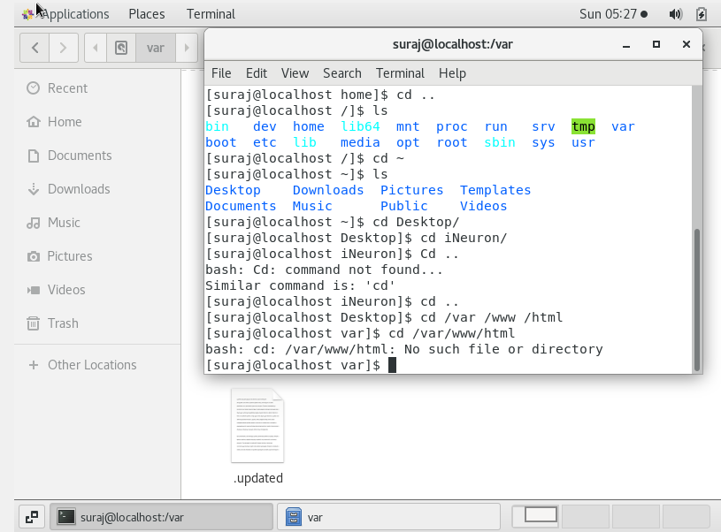

* Now type **cd /root** and then hit **Enter** key
  + Do **ls,** check any output we have on screen if yes then take screenshot?

ANS:

When performed cd /root it gives error that permission is denied.

Since I logged in as a user and it’s not root hence it happening.

If I first login as a root then I can access the Root folder.

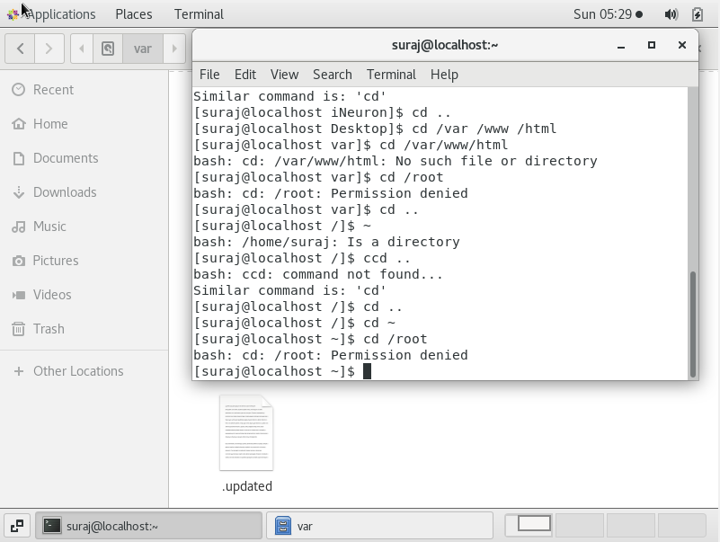

**Assignment-4**

Working with File Listing

* Go to **cd /etc** and type **ls**
  + Take screenshot and explain what files you have seeing?
  + Take screenshot and explain what different output you found compare to previous command you used?

ANS:

It lists all the files in etc folder. etc folder is present in Computer.

Look like it has listed all the files that are present in the folder.

Here we got a list of all the folder and files.

Earlier we used to get the name of folder within two lines here it listed all the folder and files here.

Also the different files and folder and highlighted in different colour.

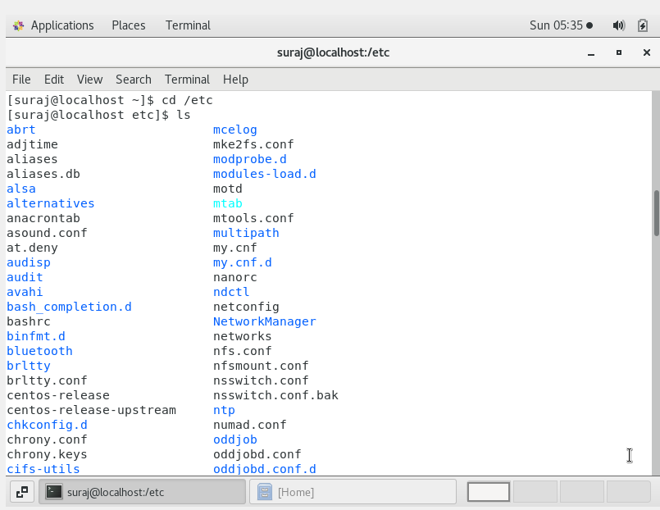

* Then type **ls -al** and hit **Enter** key
  + Take screenshot and explain what new file or directory you found?

ANS:

Ls -al shows the permissions of the files and folder present in etc.

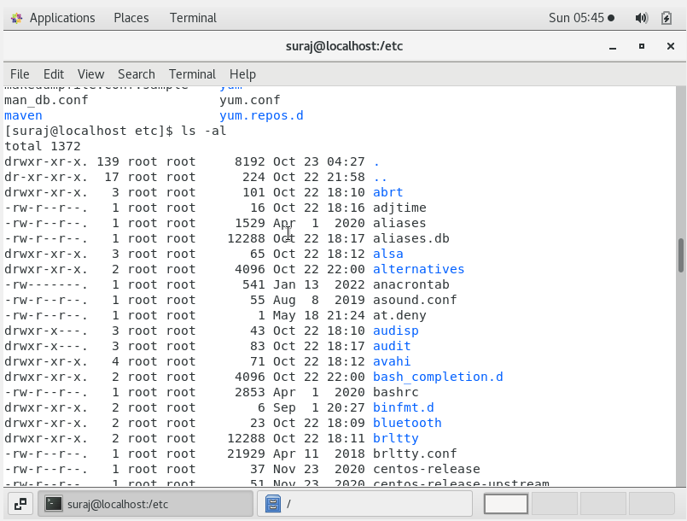

* Then use **ls -i** and hit **Enter** key
  + Now see what different output its shows and take screenshot?

ANS:

Ls -i shows the index node number of all directories and files.

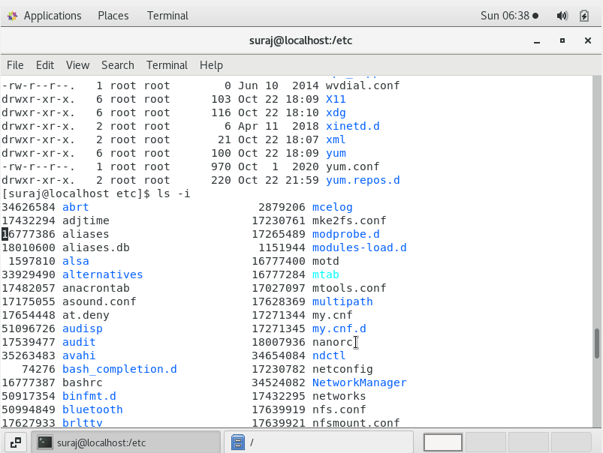

* Then use **ls –help** and see other options about **ls** command
  + Explore it and try with other attribute we can use with **ls** command

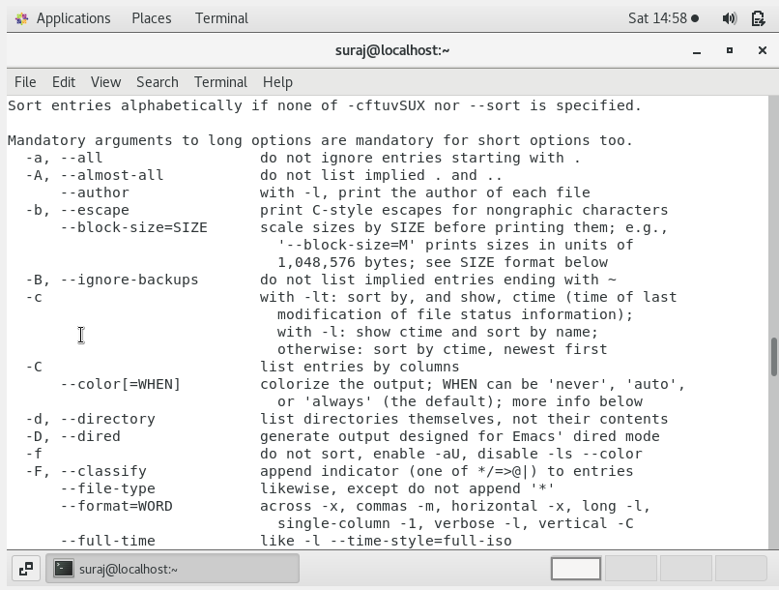ANS: